NATIONAL FEDERATION OF YOUNG FARMERS’ CLUBS
Competition Programme 2022-23

NFYFC Fence Erecting
Status Final
AFI Recommendations May 2022
Sponsored by ‘EstateWIRE’ – part of ArcelorMittal

R U L E S
Competition Aim
To provide an opportunity for members to demonstrate the acquired skill in building stock proof fence in a competitive environment.

Learning outcomes
A knowledge of planning and building of a stock proof fence using practical skills in fence erecting, budgeting for materials, acquiring materials, use of hand tools and teamwork.

REMINDER: Please read these rules in conjunction with NFYFC General Rules and familiarise all competitors with the Fine System in place for withdrawal from competitions.
Further information can be found at http://www.nfyfc.org.uk/competitionsresources

- DATE & VENUE
  - After Area Finals, the National Final will be held at NFYFC Competitions Day on Saturday, 8th July 2023.

- REPRESENTATION
  - Counties may enter one team per 600 members or part thereof in Area Finals.
  - Areas will be represented in the final by one team per 3,000 members or part thereof. (Northern Area 2, Eastern Area 1, East Midlands Area 1, West Midlands Area 1, South West Area 2, South East Area 1 and Wales 2)

- ELIGIBILITY
  - A team shall consist of three (3) members 28 years of age or under on 1st September 2022, and full members of a Club affiliated to the NFYFC.

- SUBSTITUTION
  - If two or more of the original team are unable to go forward to subsequent rounds, then the next highest placed team will represent the Area.
  - All substitutes must have been eligible to compete in the County Final.

HEALTH & SAFETY – ESSENTIAL READING/ACTION FOR ALL COMPETITORS
It is essential that all competitors read the Health and Safety Executive’s guidance paper concerning fencing and note is taken of the safe working practices and protective clothing equipment that is recommended. The Health and Safety Executive guidance paper ‘Fencing’ (AFAG104) can be downloaded from the NFYFC website.

- PROCEDURE
  - At the NFYFC Final the team will be required to erect a 22m stock proof boundary fence using the materials provided (as illustrated in the diagram).
    - Total height to top of fence 45 inches.
    - The posts shall be at a maximum of 4m centres, with intermediate posts at equal spacing.
  - From the start point; the fence shall be in a straight line for 12m before turning approximately 30⁰ to the right and continuing for a further 10m.
  - It shall be constructed of post and netting with 2 strands of high tensile steel wire above the netting.
    - One strand of high tensile wire (ground wire) to be placed 2” off the floor.
    - The netting shall be set 2” above the ground wire.
    - There shall be 2 strands of high tensile plain wire above the netting, set at 2” & 5” above the top of the netting – ie, 2” between the netting and lower wire, then 3” between the 2 wires.
    - Netting shall be secured to the end strainers using a recognised knot.
  - At one end of the fence there will be a box strainer assembly using a horizontal strut and diagonal brace wire.
    - The box strainer shall be made with 2 x 8’ strainers and an 8’ horizontal brace, with 2.5 HT plain wire.
    - The horizontal brace shall be morticed into the strainers on both ends.
  - At the other end, the fence will be secured with a strainer assembly.
    - The assembly shall be made using an 8’ strainer and 8’ angled strut, with the strut secured using a horizontal thrust block.
    - The thrust block shall be dug 8” below ground level and be left open for judges inspection.
    - A horizontal block on the bottom of both end strainers.
    - The strut is to be morticed into the strainer at 18” to the top of the strut – ie, between the 4th and 5th wire on the net.
  - Where the fence turns 30⁰; the turning post shall be a straining post without struts.
  - A hand tied joint will be required in the netting and a hand tied joint in the top line wire; towards the centre of the fence (no joining aids will be permitted).
  - A join in the netting must be made by hand where indicated on the diagram.
  - The team are required to prepare a written risk assessment/method statement, which is to be handed to the Chief Steward on the day of the competition - prior to the competition start. Failure to provide a written risk assessment/method statement or failure to comply with it; or working unsafely, will result in immediate disqualification. Please see NFYFC Fence Erecting Risk Assessment Template below. This may be used and completed as teams wish (Risk 1 already entered as an example).

Diagram is not to scale and is for illustrative purposes only
All spacings to be determined by the competitors

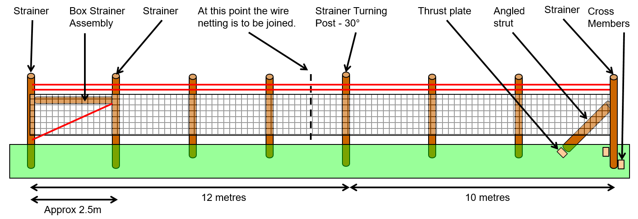

  - Only materials supplied by the organisers are to be used for Area and National Finals (see list of materials below).
  - Only hand tools will be allowed and the teams themselves must provide these. No power tools or chainsaws are allowed.
    - All tools and equipment used must be fit for purpose and be in good condition, well maintained and safely operated by members of the team at all times. Judges/stewards have the right to stop the use of tool/piece of equipment if, in their view, it is not safe to use or is being handled/used in an unsafe manner.
  - Competitors are not allowed to shorten any of the vertical posts.
  - The Judge reserves the right to inspect any strut following completion of the task.
  - All teams are required to dismantle their fence after the Presentation of Awards (The thrust plate and any blocks/cross members must be out of the ground). – Teams are required to clear away all debris and any off-cuts of wire etc must not be put down the postholes. Receptacles will be provided for this purpose. Soil will be available to make the ground good. Any team not complying with this ruling will be disqualified and receive a £75 fine.
  - The Judge’s decision is final.

- EQUIPMENT TO BE PROVIDED
4 x Strainers: 2.4m, 150mm – 150mm diameter round posts (8ft, 6” – 7”)
1 x Angled Strut: From 2.4m x 100-125mm diameter round post (8ft, 4 – 5”)
1 x Horizontal Strut: From 2.4m x 100-125mm diameter round post (8ft, 4 – 5”)
4 x Intermediate posts 1.65m x 75mm - 100mm diameter round posts (5ft 6”, 3”– 4”)
Thrust Plate and Cross Members From 1.8m x 150mm x 75mm (6ft x 6”x 3” square)

25m x High Tensile stock netting HT8/80/15 Usually 8/80/22 but 15 will be used due to lack of 22 supply this year even though 22 is recommended for this type of fence in British Standard 1722-2:2020.
75m x High Tensile plain wire 2.5mm gauge

6” Nails are to be used
Staples

- TIMING
  - 2 hours 30 minutes will be allowed for the NFYFC final.
  - Time penalties – teams will be encouraged to complete the task but will lose one (1) point for every minute or part thereof over the allocated time. At the NFYFC final teams will be asked to stop 30 minutes after the allocated time. i.e. at 3 hours.
  - Please note that the tidying of tools and equipment away will be included in the time to complete the task.
- SCALE OF MARKS
Box strainer assembly 50
High tensile fencing-strainer assembly 50
Turning post 20
Intermediate post line and height 20
Fixing and tensioning of netting 40
Fixing and tensioning of plain wire 20
Join in netting 30
Join in plain wire 10
Overall neatness of finished job 30
(Including surrounding area)
Written risk assessment 20
TOTAL 290

- AWARDS
  - Betafence National Farm Skills Challenge Cup and Prize Cards to the winning team.
  - NFYFC Prize Cards to teams placed 2nd and 3rd.
  - NFYFC Certificate of Achievement will be awarded to all members of teams in the NFYFC final.

NFYFC Fence Erecting – Risk Assessment Template

Item |  | Activity  (Description of activity and associated hazards) |  | Risk Evaluation  (No controls) |  |  |  |  |  | Safety precautions  (Details of preventative or control measure for each hazard) | Residual Risk Evaluation  (With Controls)
 |  |  |  | P |  | S |  | R |  |  | P | S | R
1 | Mild steel wire tensioned beyond breaking point causing eye damage |  | 3 |  | 4 |  | A |  | Wear suitable eye protection |  | 3 | 2 | C
2
3
4
5
6
7
8
9
10

Consequences
A; Hazard MUST be eliminated or avoided, work NOT to proceed.
B; Risk MUST be controlled by physical safeguards.
C; Risk MUST be controlled so far as is reasonably practicable.
#; Risk is adequately controlled / insignificant.
 | S1 | S2 | S3 | S4
P1 | # | # | # | C
P2 | # | # | C | B
P3 | # | C | B | A
P4 | # | B | A | A

Probability [P] Severity [S] Risk Level [R]
1; Improbable 1; Negligible
2; Remote 2; Minor
3; Possible 3: Severe
4; Probable 4: Extreme

