NATIONAL FEDERATION OF YOUNG FARMERS’ CLUBS
Status Draft
April 2019
Eliminator
Competition Programme 2019-20

NFYFC Fence Erecting
Sponsored by

R U L E S
Competition Aim
To provide an opportunity for members to demonstrate the acquired skill in building stock proof fence in a competitive environment.

Learning outcomes
A knowledge of planning and building of a stock proof fence using practical skills in fence erecting, budgeting for materials, acquiring materials, use of hand tools and teamwork.

REMINDER: Read in conjunction with NFYFC General Rules. Further information can be found at http://www.nfyfc.org.uk/CompetitionsResources/competitionsresources

- DATE & VENUE
  - After Area Finals, the National Final will be held at NFYFC Competitions Day on Saturday, 4th July, 2020.

- REPRESENTATION
  - Counties may enter one team per 600 members or part thereof in Area Finals.
  - Areas will be represented in the final by one team per 3,000 members or part thereof. (Northern Area 2, Eastern Area 1, East Midlands Area 1, West Midlands Area 1, South West Area 2, South East Area 1 and Wales 2)

- ELIGIBILITY
  - A team shall consist of three (3) members 26 years of age or under on 1st September 2019, and full members of a Club affiliated to the NFYFC.

- SUBSTITUTION
  - If two or more of the original team are unable to go forward to subsequent rounds, then the next highest placed team will represent the Area.
  - All substitutes must have been eligible to compete in the County Final.

HEALTH & SAFETY – ESSENTIAL READING/ACTION FOR ALL COMPETITORS
It is essential that all competitors read the Health and Safety Executive’s guidance paper concerning fencing and note is taken of the safe working practices and protective clothing equipment that is recommended. The Health and Safety Executive guidance paper ‘Fencing’ (AFAG104) can be downloaded from the NFYFC website.

- PROCEDURE
  - At the NFYFC Final the team will be required to erect a 13m stock proof boundary fence in a straight line, using the materials provided (as illustrated in the diagram).
  - It shall be constructed of post and netting with 2 strands of mild steel barbed wire above the netting, and one strand of mild steel plain wire below the netting.
  - At the start of the fence there will be a box strainer assembly using a horizontal strut and high tensile diagonal brace wire. At the other end; the fence will be secured with a mild steel fencing-strainer assembly, using a strainer and angled strut (strut to be secured using a thrust plate, and strainer to be secured using a cross member).
  - The plain wire and barbed wire to be tensioned and tied with a knot at both ends. There must also be a join in the plain wire using a hand tied knot where indicated on the diagram.
  - A join in the netting must be made by hand where indicated on the diagram.
  - The team are required to prepare a written risk assessment/method statement, which is to be handed to the Chief Steward on the day of the competition - prior to the competition start. Failure to provide a written risk assessment/method statement or failure to comply with it; or working unsafely, will result in immediate disqualification. Please see NFYFC Fence Erecting Risk Assessment Template below. This may be used and completed as teams wish (Risk 1 already entered as an example).

Diagram is not to scale and is for illustrative purposes only
All spacings to be determined by the competitors

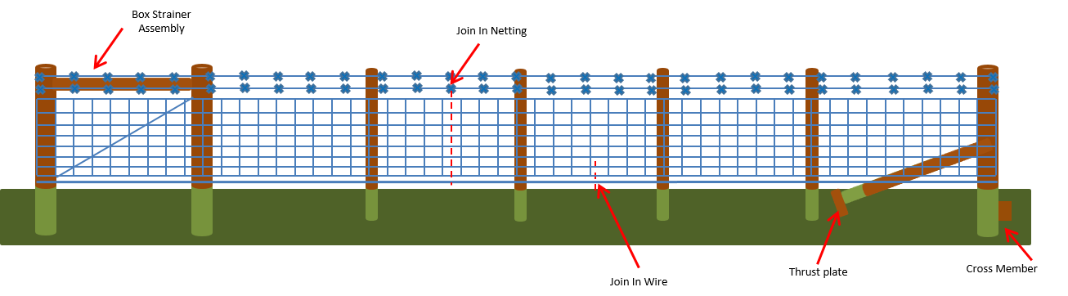

  - Only materials supplied by the organisers are to be used for Area and National Finals (see list of materials below).
  - Only hand tools will be allowed and the teams themselves must provide these. No power tools or chainsaws are allowed.
    - All tools and equipment used must be fit for purpose and be in good condition, well maintained and safely operated by members of the team at all times. Judges/stewards have the right to stop the use of tool/piece of equipment if, in their view, it is not safe to use or is being handled/used in an unsafe manner.
  - Competitors are not allowed to shorten any of the vertical posts.
  - The Judge reserves the right to inspect any strut following completion of the task.
  - All teams are required to dismantle their fence prior to the Presentation of Awards (The thrust plate and any blocks/cross members must be out of the ground). – Teams are required to clear away all debris and any off-cuts of wire etc must not be put down the postholes. Receptacles will be provided for this purpose. Soil will be available to make the ground good. Any team not complying with this ruling will be disqualified and receive a £75 fine.
  - The Judge’s decision is final.

- EQUIPMENT TO BE PROVIDED
3 x Strainers: 2.2m, 125mm – 150mm diameter round posts (7ft, 5” – 6”)
1 x Angled Strut: From 1.8m x 100mm diameter round post (6ft, 3 – 4”)
1 x Horizontal Strut: From 2.4m x 100mm diameter round post (8ft, 3 – 4”)
4 x Intermediate posts: 1.7m x 100mm diameter round posts (5ft 6”, 3 – 4”)
Thrust Plate and Cross member using: 0.9m x 100mm x 100mm square post (2ft 11”, 4”x 4”)
(Organisers cut 1.8m length x 100mm x 100mm square in 2)

16.60m x mild steel stock netting C8/80/15 (3 lots can be cut from a 50m roll)
32m x mild steel barbed wire
16m x mild steel plain wire 2.5mm gauge
18m x high tensile plain wire 2.5mm gauge

4” nails
Staples

- TIMING
  - 1 hour 30 minutes will be allowed for the NFYFC final.
  - Time penalties – teams will be encouraged to complete the task but will lose one (1) point for every minute or part thereof over the allocated time. At the NFYFC final teams will be asked to stop 30 minutes after the allocated time. i.e. at 2 hours .
  - Please note that the tidying of tools and equipment away will be included in the time to complete the task.

- County and Area rounds

  - To simplify this competition for earlier rounds and encourage participation, it is suggested that the mild steel barbed wire may be replaced with mild steel plain wire.
  - For the County and Area rounds of the competition it is suggested that the timing could be adjusted as follows:
County and Area Rounds: 2 hours with a cut off of 2 hours 30 minutes.

- SCALE OF MARKS
Box strainer assembly 50
Mild steel fencing-strainer assembly 50
Intermediate post line and height 20
Fixing and tensioning of barbed wire 20
Fixing and tensioning of netting 40
Join in netting 30
Fixing and tensioning of plain wire 20
Join in plain wire 10
Overall neatness of finished job 25
(Including surrounding area)
Written risk assessment 5
TOTAL 270

- AWARDS
  - Betafence National Farm Skills Challenge Cup and Prize Cards to the winning team.
  - NFYFC Prize Cards to teams placed 2nd and 3rd.
  - NFYFC Certificate of Achievement will be awarded to all members of teams in the NFYFC final.

NFYFC Fence Erecting – Risk Assessment Template

Item |  | Activity  (Description of activity and associated hazards) |  | Risk Evaluation  (No controls) |  |  |  |  |  | Safety precautions  (Details of preventative or control measure for each hazard) | Residual Risk Evaluation  (With Controls)
 |  |  |  | P |  | S |  | R |  |  | P | S | R
1 | Mild steel wire tensioned beyond breaking point causing eye damage |  | 3 |  | 4 |  | A |  | Wear suitable eye protection |  | 3 | 2 | C
2
3
4
5
6
7
8
9
10

Consequences
A; Hazard MUST be eliminated or avoided, work NOT to proceed.
B; Risk MUST be controlled by physical safeguards.
C; Risk MUST be controlled so far as is reasonably practicable.
#; Risk is adequately controlled / insignificant.
 | S1 | S2 | S3 | S4
P1 | # | # | # | C
P2 | # | # | C | B
P3 | # | C | B | A
P4 | # | B | A | A

Probability [P] Severity [S] Risk Level [R]
1; Improbable 1; Negligible
2; Remote 2; Minor
3; Possible 3: Severe
4; Probable 4: Extreme

